Supplementary Information

Notes
For the dataset where nutrient blood flow and absolute MMR were measured for different species within the same genus, the individuals sampled exhibit similar body sizes. For example, the nutrient blood flow value reported for Anas superciliosa by Allan et al. (2014) corresponds to a body mass of 1040 g, while the MMR value measured for Anas castanea by Rezende et al. (2002) corresponds to a body mass of 969 g.

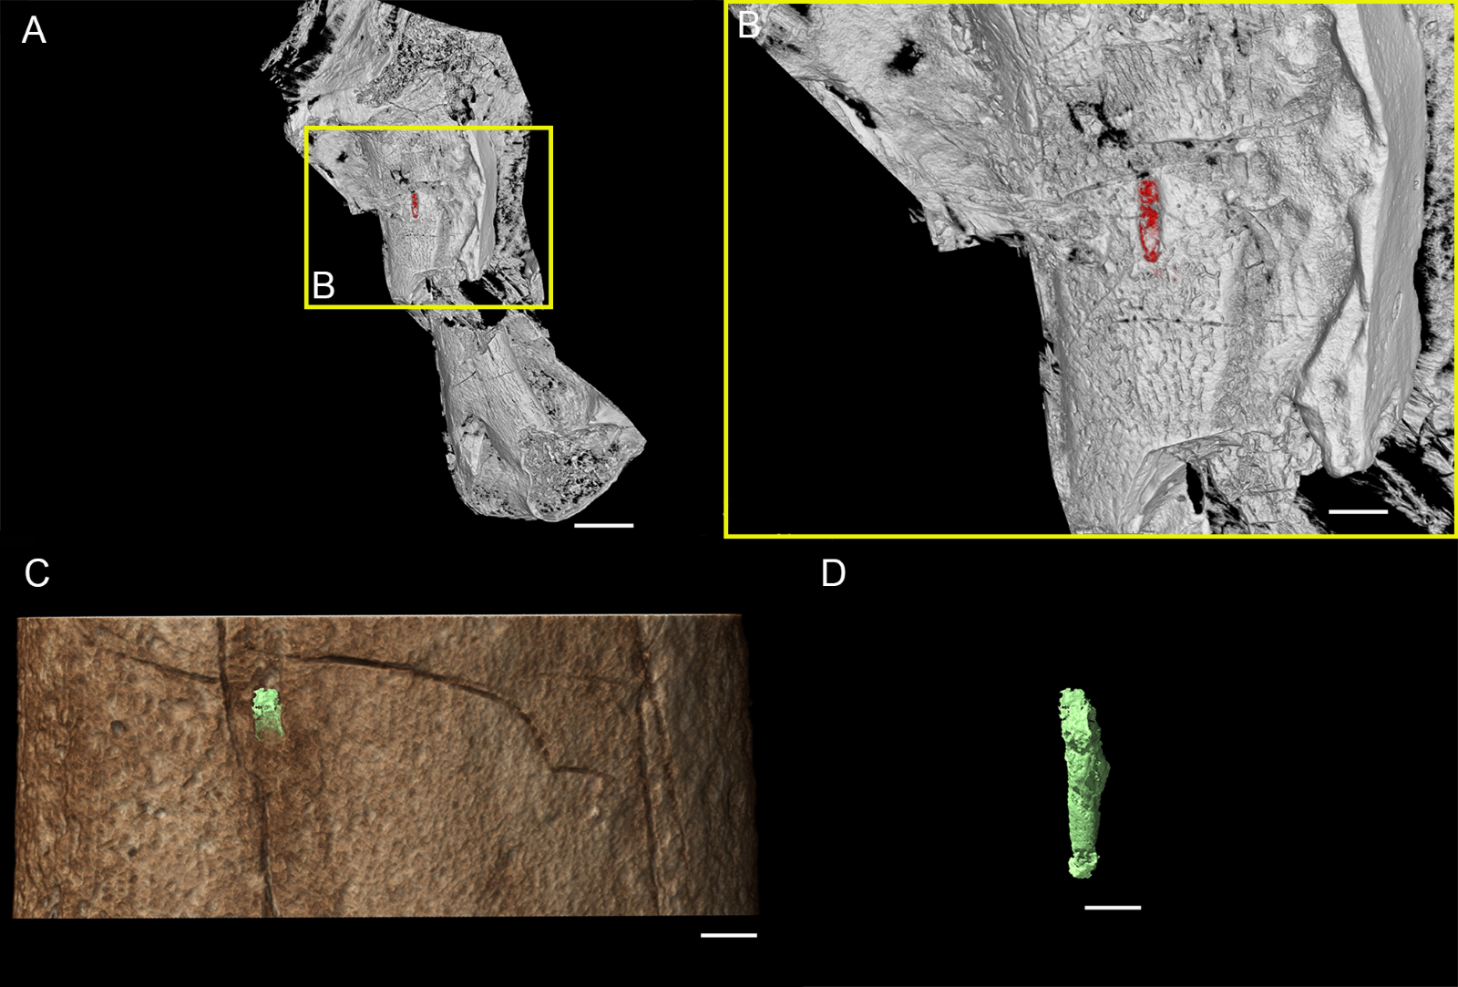
Figure S1. 3D reconstruction of femora of Rhamphorhynchus sp. MdC 20269891 (voxel size of 4.24 μm) (A) and Halszkaraptor escuilliei MPC D-102/109 using µCT (C) (voxel size of 53.58 μm), with the identifiable foramina segmented and highlighted in red (B) and green (D). Scale bar equals 2 mm (A), 600 µm (B), and 550 µm (C and D).

Supplementary References
Allan, G. H., Cassey, P., Snelling, E. P., Maloney, S. K., & Seymour, R. S. (2014). Blood flow for bone remodelling correlates with locomotion in living and extinct birds. Journal of Experimental Biology, 217(Pt 16), 2956-62. https://doi.org/10.1242/jeb.102889.

Bennett, P. M., & Harvey, P. H. (1987). Active and resting metabolism in birds: Allometry, phylogeny, and ecology. Journal of Zoology, 213, 327–344. https://doi.org/10.1111/j.1469-7998.1987.tb03708.x

Crispin, T. S. (2014). The Evolution of Metabolic Rate in Terrestrial Ectotherms. Unpublished PhD. thesis, The University of Queensland, 205 pp.

Cubo, J., Sena, M. V. A., Pellarin, R., Faure-Brac, M. G., Aubier, P., Cheyron, C., Jouve, S., Allain, R., & Jalil, N. E. (2024). Integrative paleophysiology of the metriorhynchoid Pelagosaurus typus (Pseudosuchia, Thalattosuchia). The Anatomical Record, 308(2), 394–411. https://doi.org/10.1002/ar.25548

Gans, G. & Dawson, W. R. (1976). Biology of the Reptilia. Volume 5, Physiology A. Academic Press, London, New York & San Francisco.

Grubb, B., Jorgensen, D. D., & Conner, M. (1983). Cardiovascular changes in the exercising emu. Journal of Experimental Biology, 104, 193–201. https://doi.org/10.1242/jeb.104.1.193

Hinds, D. S., Baudinette, R. V., MacMillen, R. E., Halpern, E. A. (1993). Maximum metabolism and the aerobic factorial scope of endotherms. Journal of Experimental Biology, 182, 41–56. https://doi.org/10.1242/jeb.182.1.41

Norberg, U. M. (1996). Energetics of flight. In Carey, C. (Ed.), Avian Energetics and Nutritional Ecology (pp. 199–249). Springer. https://doi.org/10.1007/978-1-4612-3508-1_7

Pontzer, H., Allen, V., & Hutchinson, J. R. (2009). Biomechanics of running indicates endothermy in bipedal dinosaurs. Plos One, 4(12). https://doi.org/10.1371/journal.pone.0007783

Rezende, E. L., Swanson, D. L., Novoa, F. F., & Bozinovic, F. (2002). Passerines versus nonpasserines: So far, no statistical differences in the scaling of avian energetics. Journal of Experimental Biology, 205(Pt 1), 101–107. https://doi.org/10.1242/jeb.205.1.101

Seymour, R. S., Runciman, S., Baudinette, R. V., & Pearson, J. T. (2004). Developmental allometry of pulmonary structure and function in the altricial Australian pelican, Pelicanus conspicillatus. Journal of Experimental Biology, 207, 2663–2669. https://doi.org/10.1242/jeb.01011

Seymour, R. S., Smith, S. L., White, C. R., Henderson, D. M., & Schwarz-Wings, D. (2012). Blood flow to long bones indicates activity metabolism in mammals, reptiles, and dinosaurs. Proceedings of the Royal Society B, 279, 451–456. https://doi.org/10.1098/rspb.2011.0968

